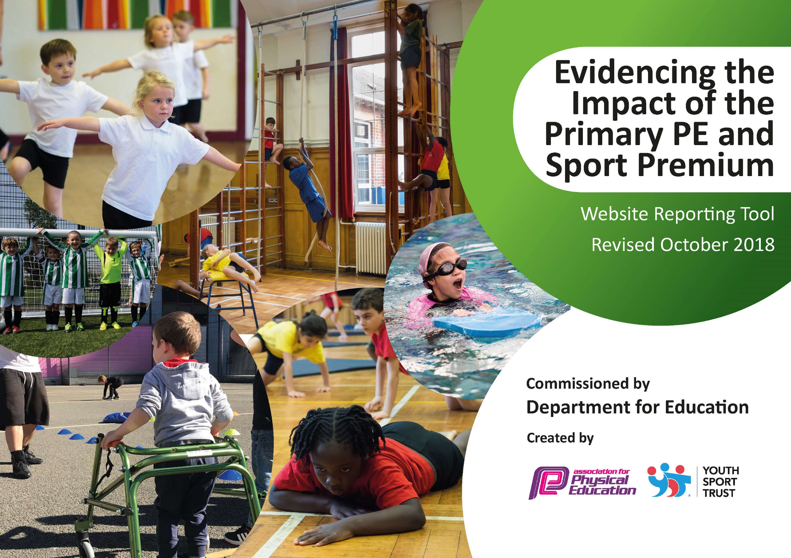
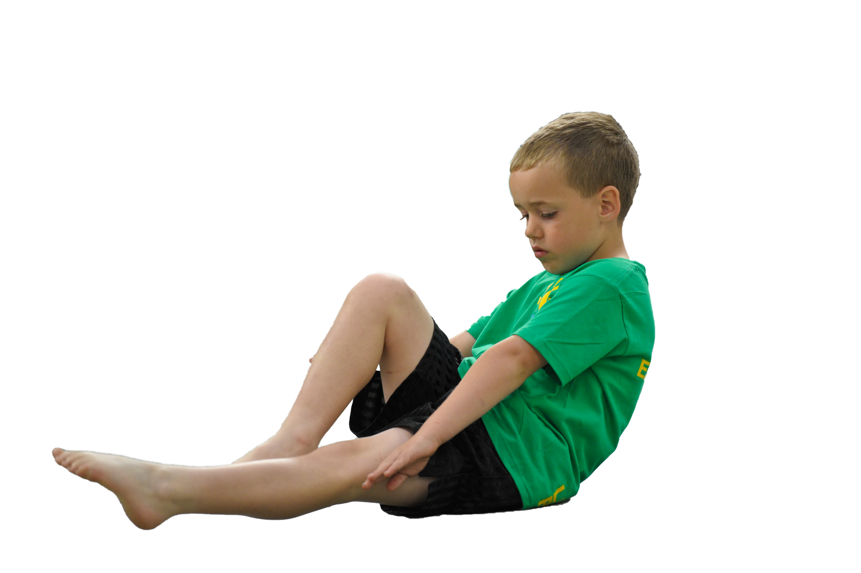
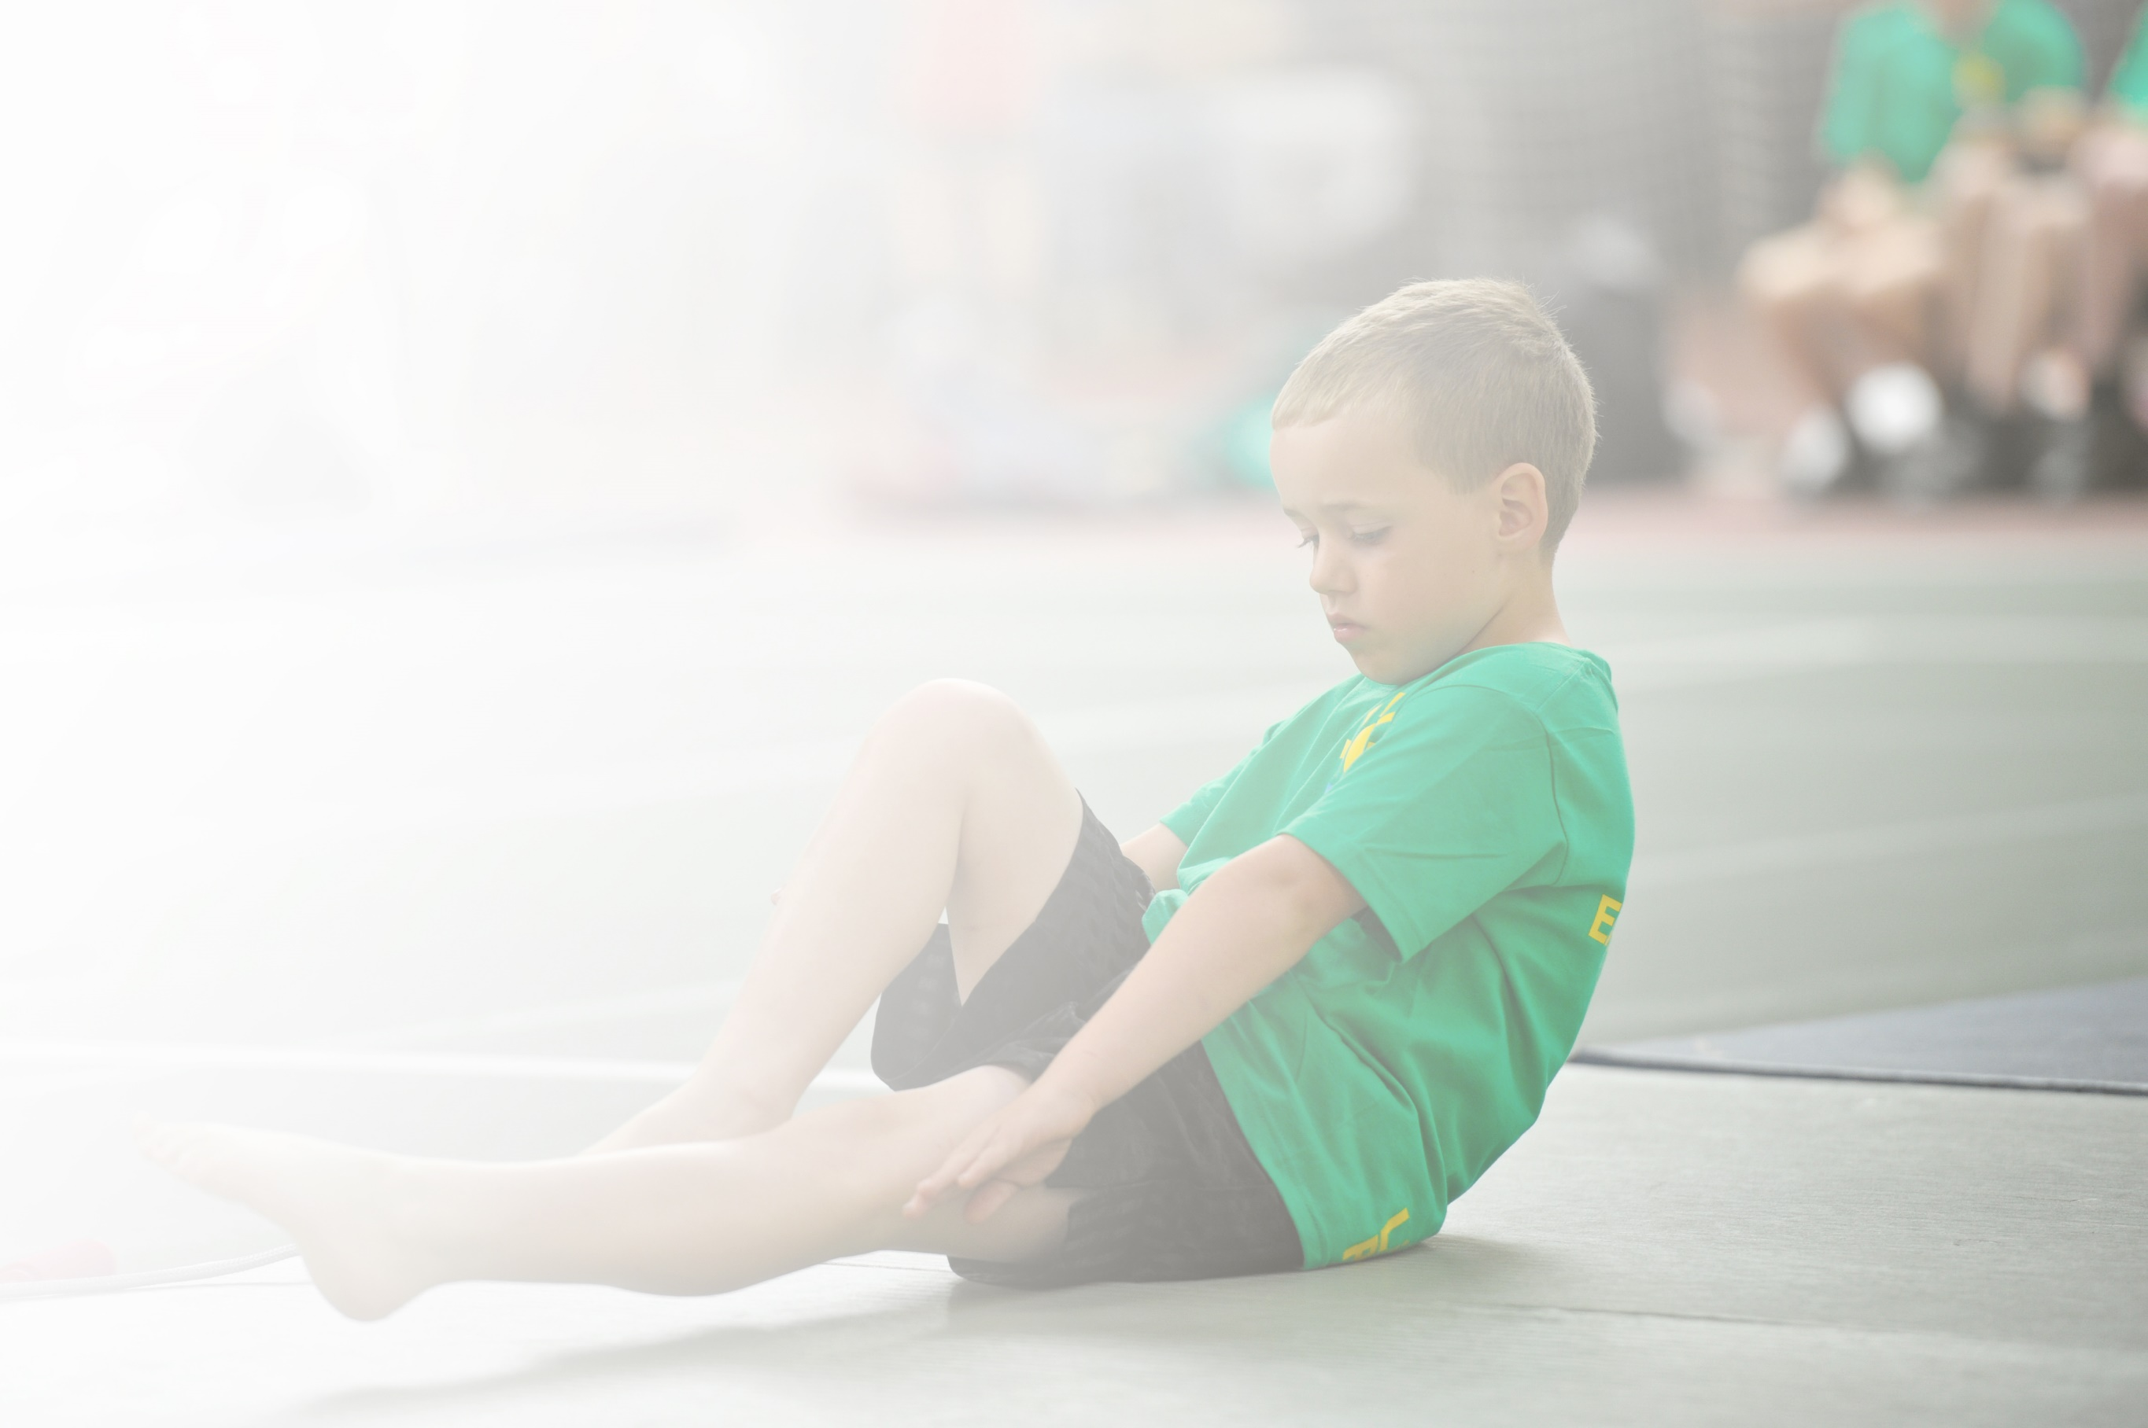
Schools must use the funding to make additional and sustainable improvements to the quality of Physical Education, Sport and Physical Activity (PESPA) they offer. This means that you should use the Primary PE and Sport Premium to:

- Develop or add to the PESPA activities that your school already offer
- Build capacity and capability within the school to ensure that improvements made now will benefit pupils joining the school in future years

Please visit gov.uk for the revised DfE guidance including the 5 key indicators across which schools should demonstrate an improvement. This document will help you to review your provision and to report
your spend. DfE encourages schools to use this template as an effective way of meeting the reporting requirements of the Primary PE and Sport Premium.

We recommend you start by reflecting on the impact of current provision and reviewing the previous
spend. Under the Ofsted Schools Inspection Framework, inspectors will assess how effectively leaders use the Primary PE and Sport Premium and measure its impact on outcomes for pupils, and how effectively governors hold them to account for this.

Schools are required to publish details of how they spend this funding as well as on the impact it has on pupils’ PE and sport participation and attainment by the end of the summer term or by 31 July 2019 at the
latest.
We recommend regularly updating the table and publishing it
on your website throughout the year, as evidence of your
ongoing review into how you are using the money to
secure maximum, sustainable impact. To see an
example of how to complete the table please
click HERE.

Support for review and reflection - considering the 5 key indicators from DfE, what development needs are a priority for your setting and your students now and why? Use the space below to reflect on previous spend, identify current need and priorities for the future.

Key achievements to date (2019/20) | Areas for further improvement and baseline evidence of need (2020/21)
Fit4Fifteen (15min daily run)  CPD for all staff  Participation in competitive matches against local schools  Updated sports kit to enable participation at local sports matches  Updated PE equipment to aid the introduction of new sports  All children receiving regular swimming lessons during the summer term  Resources available during lunchtime  Improved participation at afterschool clubs  Gloucestershire County Cricket day – Y3/4 and y5/6  . District swimming gala  KS1 multisports day.  Handball club. Gymnastics club. Netball club. Tag rugby club. Athletics club. Cross country club. Football club. Summer sports club  District winners at boy’s football for the second year running  Girls district football tournament for the first time (due to improved girls attendance at club)  Netball tournament winners  Fit4Schools assessment days  Fit4Schools support day  New sports – lacrosse, archery,curling  Runners up in the Forest Green Rovers boys football  Mini Marines  Gloucester Rugby coaching  Gloucestershire cricket club coaching  Third place level 2 netball final  Panathlon for SEND  Y3/4 rugby tournament  Y5/6 district rugby tournament  Shropshire  Flat Stan first aid training  District Rounders  District swimming gala | Sustainability of fit4fifteen - activity trackers/ staff participation/parent participation(following child questionnaires)  Continued CPD  School Games Mark  New sports (through Sports Plus)  Update sports kit  Provide continued CPD for ‘The Power of PE’ SOW  Improve signposting to local clubs through assemblies/taster days etc  Flat Stan first aid training  PE interventions to improve attitude towards physical activity/ participation

Meeting national curriculum requirements for swimming and water safety (2019/20) | Please complete all of the below:
What percentage of your current Year 6 cohort swim competently, confidently and proficiently over a distance of at least 25 metres?  N.B. Even though your children may swim in another year please report on their attainment on leaving  primary school. | Not able to assess due to lockdown (Covid19)
What percentage of your current Year 6 cohort use a range of strokes effectively [for example, front crawl, backstroke and breaststroke]? | Not able to assess due to lockdown (Covid19)
What percentage of your current Year 6 cohort perform safe self-rescue in different water-based situations? | Not able to assess due to lockdown (Covid19)
Schools can choose to use the Primary PE and Sport Premium to provide additional provision for swimming but this must be for activity over and above the national curriculum requirements. Have you used it in this way? | Not able to assess due to lockdown (Covid19)

Action Plan and Budget Tracking
Capture your intended annual spend against the 5 key indicators. Clarify the success criteria and evidence of impact that you intend to measure to evaluate for students today and for the future.

Academic Year: 2019/20 | Total fund allocated: £17,032.50 +3,939.80 c/f = 20,972.39
Key indicator 1: The engagement of all pupils in regular physical activity – Chief Medical Officer guidelines recommend that primary school children undertake at least 30 minutes of physical activity a day in school |  |  |  | Percentage of total allocation:
 |  |  |  | 46%
School focus with clarity on intended impact on pupils: | Actions to achieve: | Funding allocated: | Evidence and impact: | Sustainability and suggested next steps:
All children receive at least 2 hours of PE every week  Impact: High quality PE for all children | Sports Plus coaching  Monitoring to ensure high quality PE for all | £5,600 | All children receiving 2 hours PE each week. Supplemented with 15mins morning run each day | Continue
Play leaders and Play Coordinator to engage more children and increase activity level during playtimes  Impact: An increase in the number of children who are physically active during breaktimes | Provide Playleader training to year 6 children through KLB School | Wotton Association subscription - £110 | Increased activity during playtimes.  Playleader training provided to Year 5 children. Nov’19  Playleader training for MDS booked (did not happen due to Covid) | Playleader refresher for year 6  Playleader training for Y5/MDS
Additional coaching from Gloucester Rugby,  Impact: Children receive specialist coaching | Liaise with Gloucester Rugby to arrange coaching/after school clubs | £700 | Y5/6 children all took part in specialised rugby coaching. Autumn’19. Children signposted to DRC  Raise the profile of rugby/team sports | Liaise with Gloucester rugby club about future projects
Additional fitness testing from ‘FitforSchools’ and provide login details for children to access a personalised fitness programme at home  Impact: Children work towards personal target for their fitness and access the fitness cards at home | FitforSchools booked for assessment days  All children to be provided with home login | £2500 | F4S assessment testing identified focus children for morning run. Children provided with PE homework during lockdown | Continue fitness testing and analyse data post lockdown. Continue to provide home learning activities
Continue to promote ‘Fitforfifteen’ across the school and improve fitness levels  Impact: Children able to sustain running for a longer period of time and improve the amount of steps they take | Purchase fitness trackers  Order all weather matting | £800 | Fitness trackers being used in KS2 regularly to encourage children to improve performance. This proved very successful (pupil voice) | Individual fitness trackers to be explored (Covid regulations) Organise routes to accommodate bubbles.
PE intervention provided by sports coach for disengaged/least active children  Impact: Improved attitude towards sport and activity | Identify disengaged/least active through fitness tracking/ observations.  Pupil conferencing to baseline  Sports plus coaching | Sports Plus (see above) | Disengaged/least active children identified through assessments. Intervention put in place in Au term. Pupil conferencing shows that those children now have a more positive attitude towards PE/activity | Explore opportunities to offer interventions for least active children
Key indicator 2: The profile of PESSPA being raised across the school as a tool for whole school improvement |  |  |  | Percentage of total allocation:
 |  |  |  | 3%
School focus with clarity on intended impact on pupils: | Actions to achieve: | Funding allocated: | Evidence and impact: | Sustainability and suggested next steps:
Children’s achievements during the morning run recognised through ‘Monday Marshal’ certificates in celebration assembly  Impact: Improved effort during the morning run. Improved self esteem | Prepare Monday marshal certificates and invite parents to celebrate success | / | Monday marshal certificates given out during celebration assemblies. Parents invited to share success  Pupil voice identified that these were very effective in engaging least active children | Introduce KS1/KS2 certificate for morning run to fit in with new regulations
Sports council created  Impact: Children have an input into the developments in sports and PE across the school. | Create sports council through class votes  Arrange regular sports council meetings | / | Sports council created and added to sports board. Involved in organising tournaments/ideas to promote PE.  Raised the profile of sport/PE | Continue with this in KS2
Sports display, which is regularly updated with school team news, pictures and reports to enable the whole school to celebrate successes.  Impact: Children will want to represent the school and celebrate their successes in sports with their peers and the whole school community. | Create and update Sports at Sharpness board | / | Sports display in hall effective (Pupil voice) and changed regularly by sports council giving them responsibility to keep it updated. | Change focus of the display whilst no events taking place. Fitness focus?
Sports Newsletter to engage the parents in sporting news/events taking place at school  Impact: Create positive attitude to sport and activity | Write newsletter detailing achievements and developments in School sport and PE | / | Sports newsletter sent to all parents to update them on the sports events/activities that take place in school. Celebrate success | Once events return, start newsletter again.
Celebration assemblies where children are given the opportunity to celebrate out of school sporting achievements as well as intra and inter school events such as tournaments, festivals and galas  Impact: Children feel proud of their achievements and boosts self confidence | Prepare certificates and invite parents to celebrate sporting success | / | Intra and Inter school events celebrated through celebration assembly. Children keen to share sporting achievements during assembly time | Not possible at the moment due to no assemblies (Covid19)
Children exposed to success stories in sports - Visit from athletes.  Experience days – Archery, Sporting Dreams  Visit from Adventuremen  Impact: Children inspired by success stories/ new experiences | Book athlete visit  Organise Adventureman visit to tie in with Superhero day | £500 | Adventureman visit – Sept ‘19  Paralympic visit – Feb ‘20  Children inspired by stories of success (Sports council feedback) | Once regulations allow, invite sporting successes into school to help inspire. Include local people.
Achieve Sports Mark award  Impact: Profile of sport raised within the school community and school recognised for their success | Apply for Sports Mark award | / | Gold Sports Mark achieved | Reapply for gold award (when regulations allow)
Introduce annual awards for a range of sports  Impact: Children recognised for effort, progress and excellence in a range of sports | Order trophies for end of year assembly | £100 | Unable to do this in 2020 due to lockdown | Awards in 2021

Key indicator 3: Increased confidence, knowledge and skills of all staff in teaching PE and sport |  |  |  | Percentage of total allocation:
 |  |  |  | 21%
School focus with clarity on intended  impact on pupils: | Actions to achieve: | Funding  allocated: | Evidence and impact: | Sustainability and suggested  next steps:
Continue to provide staff CPD in areas of their choice.  Impact: Confident staff who provide high quality, engaging lessons which motivate pupils to achieve their potential. | Discussion with staff about CPD requirements  Power of PE CPD provided where requested  CPD courses if appropriate |  | Staff questionnaire identified that all staff feel confident with no specific CPD needs at present. | Continue in house CPD where necessary. Find appropriate PE courses if required
CPD received from Gloucester Rugby Club, Gloucestershire County Cricket Club and Sports Plus  Impact:  Staff confident in the delivery of Rugby/cricket and new sports (Sports plus) | Sports Plus booked for CPD across all classes. By the end of the unit, staff should be leading the sessions with the support of the coach.  Gloucester Rugby and Chance to Shine booked | Cost of Gloucester Rugby  Cost of Chance to Shine (see above) | Continued CPD provided through Sports Plus  CPD from Gloucester Rugby club. Resulted in increased confidence in teaching PE (staff feedback) | Continue CPD using outside agencies  Provide cricket coaching (Nov 21)
Provision of high quality equipment. Impact: Staff are able to deliver lessons effectively with the correct amount of equipment | Purchase high quality equipment which will maintain good condition over time to enable staff to confidently deliver a range of different sports and activities. | £4,000 | New equipment provided ensuring staff can deliver effective lessons | Purchase new equipment where necessary
Use Insight to ensure all skills are taught and children’s attainment tracked  Impact: Staff will be able to identify achievements of all children in their classes and their next steps in learning. PE Lead / SLT can track key groups across the school to ensure their needs are being met. | Staff meeting to discuss use of Insight to track attainment in PE | / | Insight regularly updated and used to inform planning | Continue to use Insight to assess progress and inform planning
PE lessons differentiated appropriately to support/challenge less able/more able  Impact:  All children are challenged/supported appropriately to ensure at least good progress | Provide CPD where necessary(identified through staff conferencing)  Lesson observations |  | Children supported/challenged appropriately (evident through lesson observations) | Ensure lessons cater for all abilities (lesson observations)
Key indicator 4: Broader experience of a range of sports and activities offered to all pupils |  |  |  | Percentage of total allocation:
 |  |  |  | 17%
School focus with clarity on intended  impact on pupils: | Actions to achieve: | Funding  allocated: | Evidence and impact: | Sustainability and suggested  next steps:
As well as offering the opportunity to play traditional games, children should be given a broad experience of different sports and activities  Impact: broad, balanced and engaging curriculum for all pupils and staff | Sports Plus to introduce a wide range of new sports  Pupil conferencing to establish which sports children would like to play | Sports Plus cost (see above) | Sports plus providing range of activities including uni hoc, skateboard hockey, archery | Continue to introduce a range of ‘new’ sports
Ability to extend and broaden the range of sports and activities already provided in school opportunities, through affiliation of District Sports Associations – Dursley Association and Wotton Association. | Join District sports associations  Attend regular meetings to organise tournaments/festivals/galas | Dursley District association subscription £25  Wotton Association subscription (see above) | Boys football district  Boys football county  District netball  Gloucester rugby tournament  Y3/4 FGR football  Y5/6 FGR football  District girls football  Cross country | Join Dursley District association  Join Wotton association
Provide a range of extra-curricular activities in a range of sports  Impact: Increased percentage of children attending after school clubs | Pupil conferencing to establish clubs  Book Gloucester rugby/Chance to Shine cricket/ Sports plus | Cost of Glos rugby/chance to shine/Sports Plus (See above) | Gloucester rugby  Gym (KS1)  Lego club, Netball club, Football club  Rugby club, Badminton club, Cross country club, Multi sports club (KS1) | Explore using outside agencies to broaden the choice of extra curricular clubs
All children provided with basic first aid training  Impact:  Children more confident to deal with medical emergencies | Book Flat Stan training | £600 | Flat Stan training unable to take place (Covid19) | Book Flat Stan
Provide Mini Marines training for all year groups throughout the school  Impact: Improved resilience. Greater understanding of healthy lifestyles | Book Mini Marines | £3,000 | Mini marines worked with Y5/6 during the autumn term. Heightened costs meant that it was no longer good value for money. Up to this point, all year groups have received mini marine coaching
Key indicator 5: Increased participation in competitive sport |  |  |  | Percentage of total allocation:
 |  |  |  | 4%
School focus with clarity on intended  impact on pupils: | Actions to achieve: | Funding  allocated: | Evidence and impact: | Sustainability and suggested  next steps:
Enter a wider range of competitions through local sports association and School Games.  Impact: More children entering intra school competitions in different sports | Continue to be part of active district associations. | £800 | Boys football district  Boys football county  District netball  Gloucester rugby tournament  Y3/4 FGR football  Y5/6 FGR football  District girls football  Cross country | Join local associations so that we can play in local tournaments (when restrictions are lifted)
Introduce annual inter-house sports competitions in a range of sports across the school.  Impact: More children entering inter school sports competitions in different sports | Sports council to organise inter house competitions in a range of sports | / | Interhouse rounders, rugby, football. No others were able to take place due to lockdown | Continue with inter house school competitions when possible
Enter more competitions within the district aimed at those less engaged/least active children  Impact: Boost self esteem and change attitudes towards PE for the less engaged/least active children | Continue to be part of active district associations. | District association cost (see above) | Penathlon booked but cancelled due to Covid19 | Look for opportunities for less engaged children to enter competitions
Improve links with local sports clubs  Impact: Children signposted to local clubs | PE coordinator to contact local clubs and organise taster days/ assemblies/leaflet drops.  PE lead to add local club contacts to display | / | Gloucester rugby club  Dursley running club  Dursley Rugby club  Severnside football club  FGR football club | Continue to make links with local sports clubs. Add to sports display

