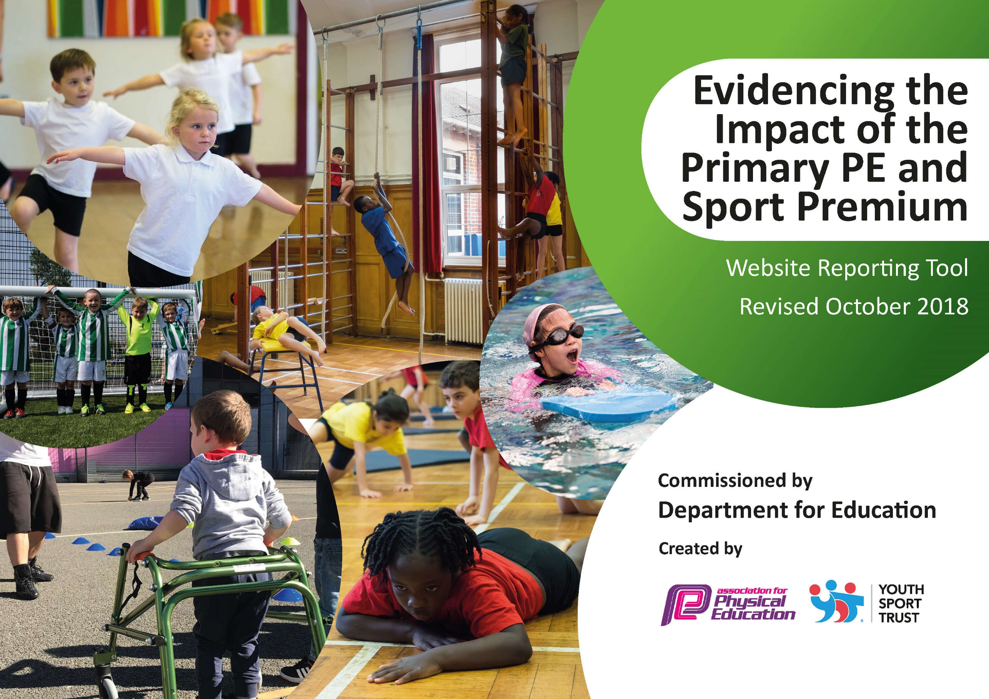
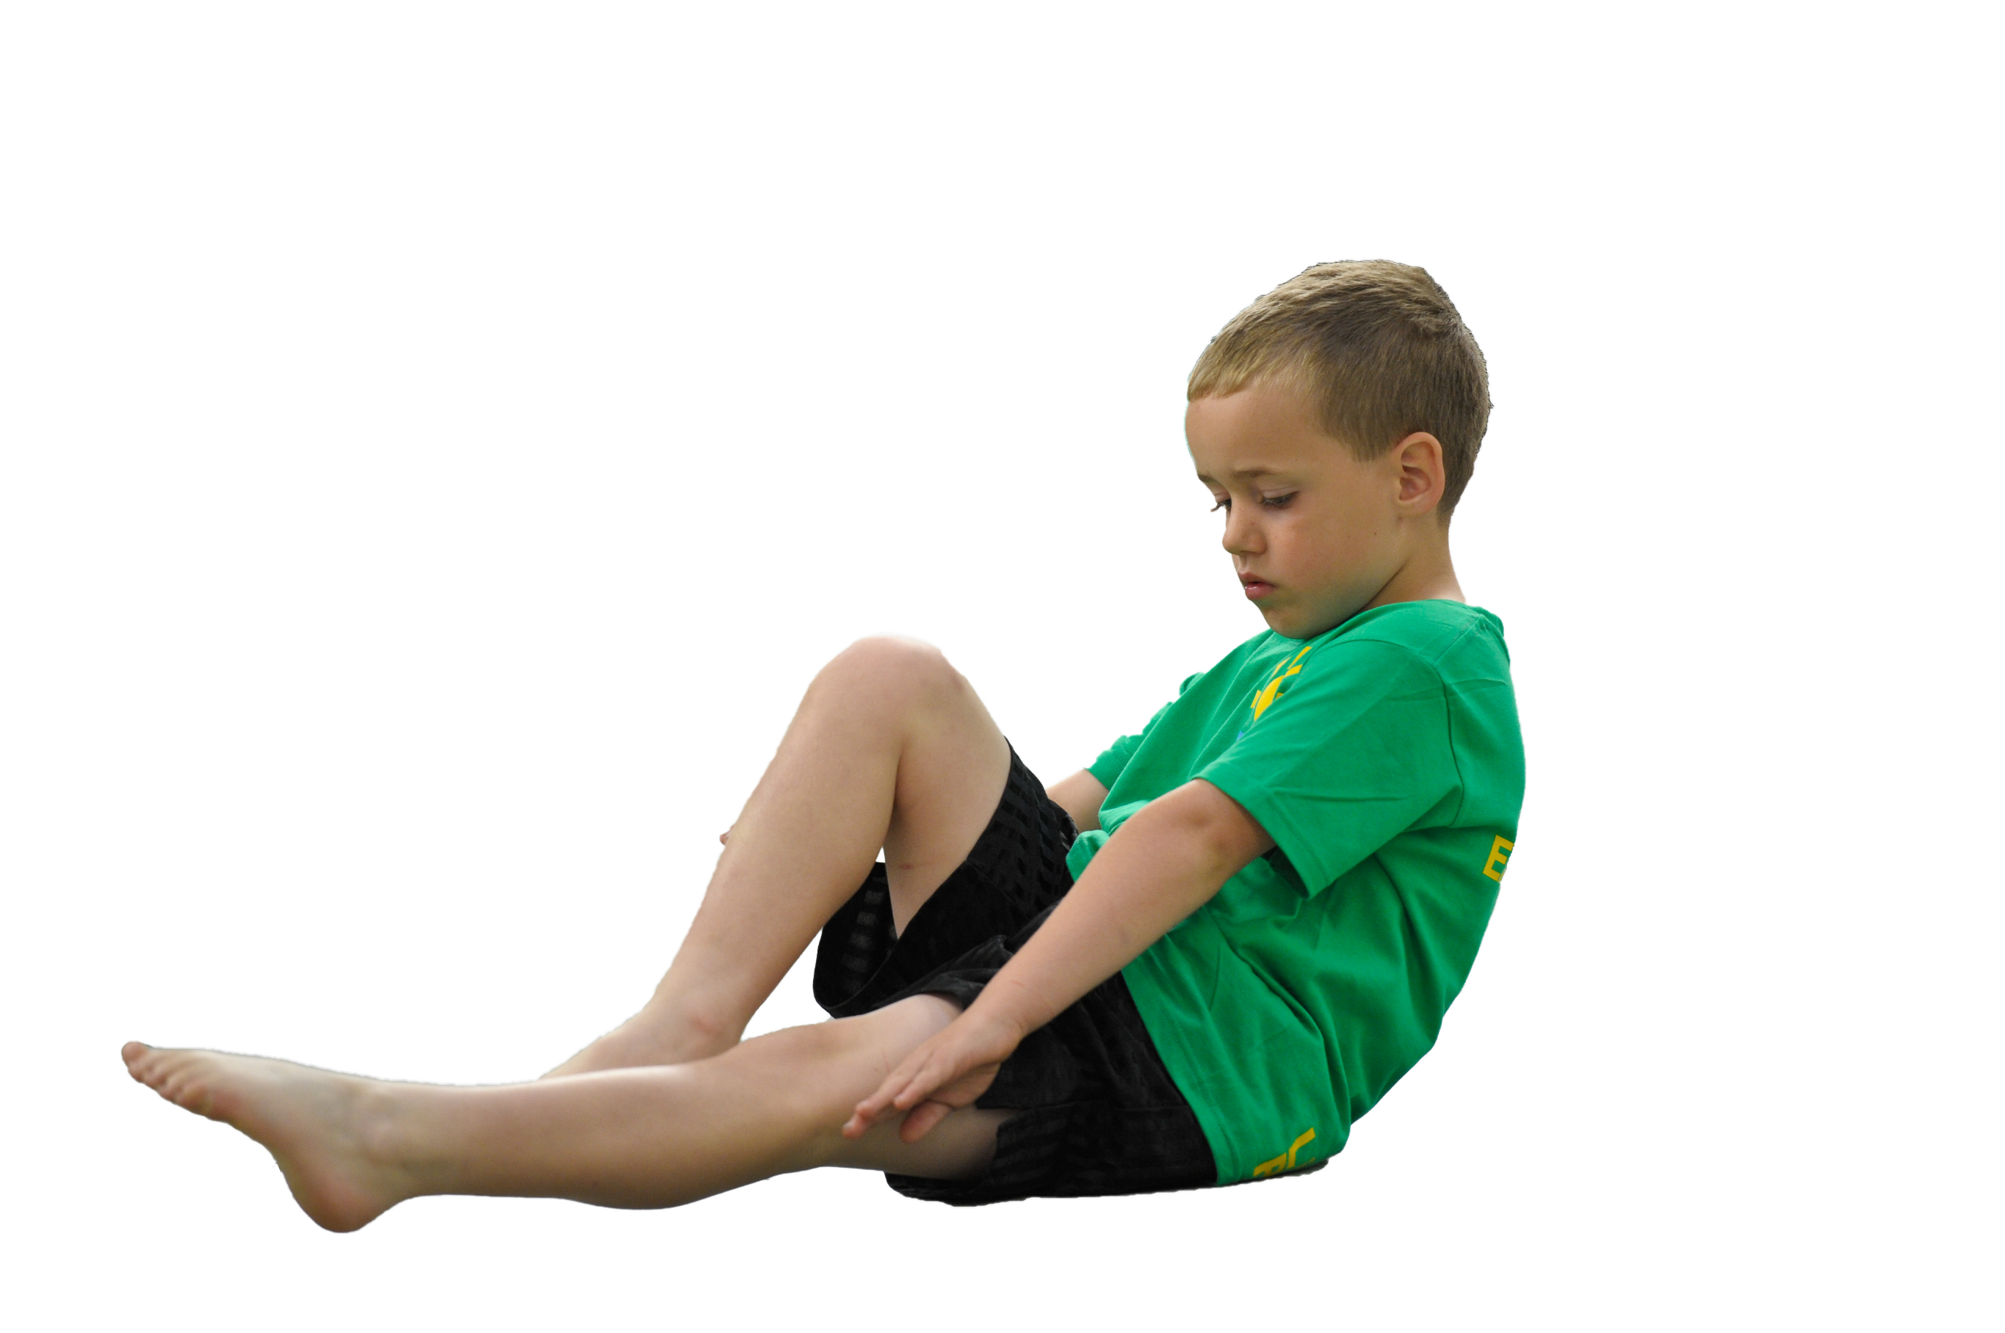

Schools must use the funding to make additional and sustainable improvements to the quality of Physical Education, Sport and Physical Activity (PESPA) they offer. This means that you should use the Primary PE and Sport Premium to:

- Develop or add to the PESPA activities that your school already offer
- Build capacity and capability within the school to ensure that improvements made now will benefit pupils joining the school in future years

Please visit gov.uk for the revised DfE guidance including the 5 key indicators across which schools should demonstrate an improvement. This document will help you to review your provision and to report
your spend. DfE encourages schools to use this template as an effective way of meeting the reporting requirements of the Primary PE and Sport Premium.

We recommend you start by reflecting on the impact of current provision and reviewing the previous
spend. Under the Ofsted Schools Inspection Framework, inspectors will assess how effectively leaders use the Primary PE and Sport Premium and measure its impact on outcomes for pupils, and how effectively governors hold them to account for this.

Schools are required to publish details of how they spend this funding as well as on the impact it has on pupils’ PE and sport participation and attainment by the end of the summer term or by 31 July 2019 at the
latest.
We recommend regularly updating the table and publishing it
on your website throughout the year, as evidence of your
ongoing review into how you are using the money to
secure maximum, sustainable impact. To see an
example of how to complete the table please
click HERE.

Support for review and reflection - considering the 5 key indicators from DfE, what development needs are a priority for your setting and your students now and why? Use the space below to reflect on previous spend, identify current need and priorities for the future.

Key achievements to date (2017/18) | Areas for further improvement and baseline evidence of need(2018/19)
Fit4Fifteen (15min daily run)  CPD for all staff  Participation in competitive matches against local schools  Updated sports kit to enable participation at local sports matches  Updated PE equipment to aid the introduction of new sports  All children receiving regular swimming lessons during the summer term  Resources available during lunchtime  Improved participation at afterschool clubs  District winners at football, County winners at football, Regional finalalists  Played at Twickenham (rugby) Gloucester rugby festival. Gloucester rugby coaching programme  Gloucestershire County Cricket day  District Rounders tournament. District Cricket tournament. District field events. District track events. District Hockey. District Netball. District rugby  Fit4 Schools. Sharkly Gala. District swimming gala  KS1 multisports day. Handball club. Street dance club. Tag rugby club. Athletics club. Cross country club. Football club. Summer sports club  Archery day. Quidditch day. Marines day. Young leaders day | Sustainability of fit4fifteen track during adverse weather  Continued CPD  New sports including archery and lacrosse  First aid training provided for all  Update sports kit  Training for swimming coaches  Introduce and provide CPD for ‘The Power of PE’ SOW

Meeting national curriculum requirements for swimming and water safety | Please complete all of the below:
What percentage of your current Year 6 cohort swim competently, confidently and proficiently over a distance of at least 25 metres?  N.B. Even though your children may swim in another year please report on their attainment on leaving  primary school. | 93%
What percentage of your current Year 6 cohort use a range of strokes effectively [for example, front crawl, backstroke and breaststroke]? | 93%
What percentage of your current Year 6 cohort perform safe self-rescue in different water-based situations? | 100%
Schools can choose to use the Primary PE and Sport Premium to provide additional provision for swimming but this must be for activity over and above the national curriculum requirements. Have you used it in this way? | Yes/No

Action Plan and Budget Tracking
Capture your intended annual spend against the 5 key indicators. Clarify the success criteria and evidence of impact that you intend to measure to evaluate for students today and for the future.

Academic Year: 2018/19 | Total fund allocated: £17,015 + £5,988.05 c/f = £23,003.05 |  |  | Date Updated:15/04/19
Key indicator 1: The engagement of all pupils in regular physical activity – Chief Medical Officer guidelines recommend that primary school children undertake at least 30 minutes of physical activity a day in school |  |  |  |  | Percentage of total allocation:
 |  |  |  |  | 26%
School focus with clarity on intended impact on pupils: | Actions to achieve: | Funding allocated: | Evidence and impact: |  | Sustainability and suggested next steps:
All children to take part in at least 30 minutes of physical activity a day | At least 2 hours of PE taught each week  15 minutes daily run  Play leaders to encourage active play during break times/lunchtimes  \sports coach to provide sporting opportunities during Monday lunchtime  A variety of after school clubs offered | Matting - £220  Affiliation to Wotton district sports subscription - £100  Sports Plus - £5,590 | Children’s fitness levels increased (Fit4Schools)  Children more active during ‘free play’ times  Increased participation at after school clubs |  | Introduce new incentive for daily mile to ensure continued engagement  Cost of sports coaches budget dependent
Key indicator 2: The profile of PESSPA being raised across the school as a tool for whole school improvement |  |  |  |  | Percentage of total allocation:
 |  |  |  |  | 23%
School focus with clarity on intended impact on pupils: | Actions to achieve: | Funding allocated: | Evidence and impact: |  | Sustainability and suggested next steps:
Profile of PE raised across the school  Percentage of children attending after school clubs/tournaments increased (particularly girls) | PE focus days including visits from athletes  With the ball dance club  Sporting Dreams  Archery day  PE conference identifying children’s participation at after school clubs/out of school clubs and views towards exercise/PE  Introduce new after school clubs following feedback from questionnaire  Provide sports kit for children to wear to tournaments  Fit4Schools  Mini Marines | Experience days - £1,000  PE coordinator time £100  Kit - £1,000  Fit4Schools - £3,094 | Profile of PE raised across the school- pupil conferencing  More children attending after school clubs/out of school clubs/ tournaments (especially girls) |  | Repeat pupil conferencing to ascertain pupils changing views and attitudes  Audit variety of after school clubs offered and continue to respond to children’s requests (from pupil conferencing)  Continue to update sports kit where necessary.

Key indicator 3: Increased confidence, knowledge and skills of all staff in teaching PE and sport |  |  |  | Percentage of total allocation:
 |  |  |  | 8%
School focus with clarity on intended  impact on pupils: | Actions to achieve: | Funding  allocated: | Evidence and impact: | Sustainability and suggested  next steps:
Quality of teaching in PE to be consistently good –  Staff more confident in the delivery of PE  PE lessons focused on NC objectives  PE lessons differentiated appropriately to support/challenge less able/more able | CPD for all staff delivered by Sports Plus  Team teaching with Sports Plus coach  CPD for new scheme of work – The Power of PE  CPD courses  New equipment to support delivery of NC | Cost of Sports Plus coach  ‘The Power of PE’ - £350  CPD - £300  Equipment - £1,000 | Lesson observations  Feedback from Sports Plus Coach  Staff questionnaire  Lessons pitched appropriately and adapted to suit individuals  All children making good progress in PE  Pupil conferencing | Ensure all staff continue to improve practice through CPD/observations/staff questionnaires  Continue to provide ongoing CPD for Power of PE
Key indicator 4: Broader experience of a range of sports and activities offered to all pupils |  |  |  | Percentage of total allocation:
 |  |  |  | 24%
School focus with clarity on intended  impact on pupils: | Actions to achieve: | Funding  allocated: | Evidence and impact: | Sustainability and suggested  next steps:
As well as offering the opportunity to play traditional games, children should be given a broad experience of different sports and activities | Shropshire Residential  Sports Plus  Fit4Schools  Flat Stanley – first aid training for all  Chance to Shine cricket  Links with Gloucester Rugby  Children signposted to local clubs where appropriate  Swimming for children not meeting NC requirements  Mini Marines | Sports Plus coach  Fit4 Schools cost  Flat Stanley- £525  £500  £4,500 | Children aware of, and given the opportunity to take part in a wider range of sports and activities  Increased participation in a range of sports and activities | Continue to make links with other organisations to provide arrange of sports and activities. Through CPD, improved confidence amongst staff allows for a broader range of sports to be offered through the curriculum
Key indicator 5: Increased participation in competitive sport |  |  |  | Percentage of total allocation:
 |  |  |  | 4%
School focus with clarity on intended  impact on pupils: | Actions to achieve: | Funding  allocated: | Evidence and impact: | Sustainability and suggested  next steps:
Increase the number of tournaments/festivals/matches | Inter house competitions  DDPSSA competitions  Local matches  Sharkly Gala | £800 | Increased participation at local tournaments/festivals/matches | Look at School Games calendar for 2019/2020 academic year when it’s released and decide which events to participate in with Sports Council. Continue to send B teams to appropriate events.  Sports council to be involved in the organisation of Inter house tournaments

