Topic Homework

Create some instructions to tell someone how to brush their teeth. This could be written or drawn instructions.  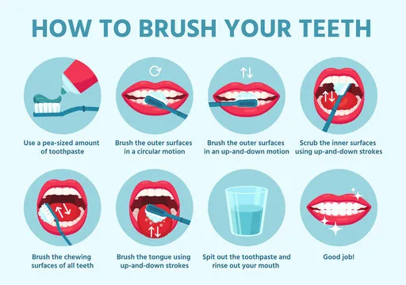 | Create a sculpture of your choice made out of paper. You could always have a go at some Origami!  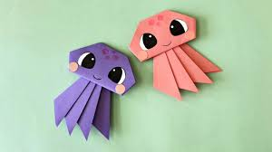
Create an exercise routine that will help us to keep our bodies fit – We will use these within our PE sessions.  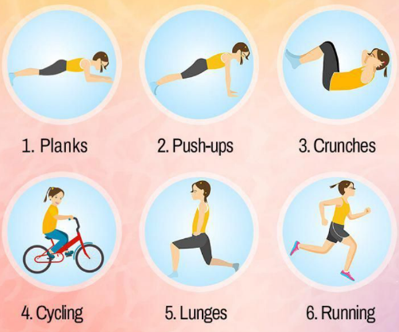 | Find out what toys your Mum or Dad used to play with when they were your age. You could bring in a photo, picture or information to share with the class.  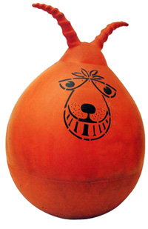
You can complete any or all of the activities below. Please could you bring your work into school when completed, so we can share it with the class.

