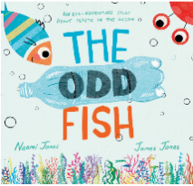
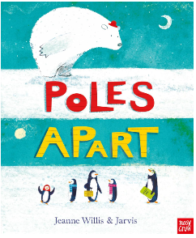
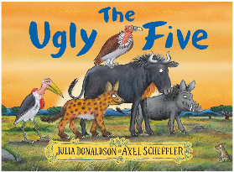
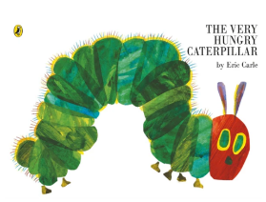
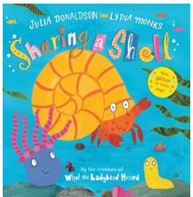
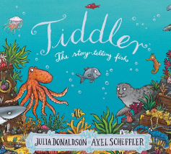
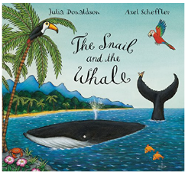
Personal, Social and Emotional Development
Scarf- Being my best & growing and changing
Bouncing back when things go wrong.
Yes, I can.
Healthy eating and my healthy mind
A good night’s sleep.
Life stages – plants, humans, animals
Me and my body – girls and boys

Literacy
We will build on the children’s early reading and writing skills with increasing confidence and independence. They continue to develop their phonics knowledge, using it to read words and simple sentences more fluently and with understanding. Children are encouraged to read a range of texts, including stories, non-fiction, and simple captions.
In writing, children begin to compose their own sentences, using their phonics knowledge to spell words and record their ideas. There is a growing focus on writing for different purposes, such as stories, descriptions, and simple information texts. Children are supported to use capital letters, full stops, and finger spaces more consistently.
Through a language-rich environment, children also develop their speaking and listening skills, sharing ideas, retelling stories, and building vocabulary. By the end of the term, children show greater confidence in reading and writing, preparing them for Year 1.

Understanding the world
This term, the children will explore the natural world and different environments through exciting, hands-on experiences. They learn about planting and lifecycles, observing how things grow and change over time. Children investigate minibeasts and marine life, as well as exploring oceans and their importance.
They also develop an understanding of different places around the world, including Africa and the polar regions, comparing these to their own environment. Through discussions about travel and journeys, children begin to understand how people explore and experience the wider world. These experiences help to build curiosity, observation skills, and a deeper understanding of the world around them.

Phonics
Daily phonic sessions through Bug Club Phonics.
Phase 3 unit 10 ar, or, ur, ow, oi
Phase 3 unit 11 ear, air, ure, (ur as ‘er’)
Phase 3 tricky words you, all, was
Phase 4 unit 12 Adjacent consonants (CVCC , CCVC)
Phase 4 tricky words said, have, like, so, do, some, come, little, one, were, out, what, when, there.

Expressive arts and design
This Term, the children build on their previous experiences to develop greater creativity, independence, and confidence in their expressive work. They will explore a wider range of materials, tools, and techniques, using them with increasing control and purpose.
They will be encouraged to plan and develop their own ideas, drawing on their imagination as well as their observations of the world around them. They experiment with colour, texture, form, and design, creating more detailed drawings, paintings, and models. There is a growing focus on refining skills such as cutting, joining, shaping, and constructing, allowing the children to create more complex and purposeful pieces.
Through collaborative projects and independent creations, the children will learn to talk about their work, explain their choices, and reflect on what they might change or improve. They also explore the work of artists and designers, using this as inspiration for their own creations.
During out music lessons we will be earning about what makes a musical instrument, the four different groups of musical instruments, following a beat using an untuned instrument and performing a practised song to a small audience. During Summer 2 we will be using our voices, bodies and instruments to explore different types of transport, identify and mimic transport sounds and interpret and perform a simple score.

Mathematics
In the Summer Term, our learning remains practical and engaging, with a strong focus on deepening understanding, fluency, and confidence.
Number & Place Value
• Counting confidently beyond 10, including recognising patterns in the number system.
• Developing a secure understanding of numbers to 10 and beginning to explore numbers to 20.
• Subitising larger quantities and recognising structured arrangements (e.g. dice patterns, ten frames).
• Exploring the composition of numbers, understanding how numbers can be made in different ways.
Addition & Subtraction
• Solving addition and subtraction problems using a range of strategies
• Beginning to recall number bonds to 5 and 10
• Using practical resources, visual representations (such as ten frames), and simple number sentences
• Explaining their reasoning using mathematical language and justifying their answers
Shape, Space & Measure
• Exploring more complex patterns, shapes, and spatial relationships
• Describing position and direction using appropriate vocabulary
• Comparing and ordering objects by length, height, weight, and capacity with increasing accuracy
• Beginning to measure using non-standard units and developing an understanding of time.

Communication and Language
We will support children’s communication and language development through exciting themes such as ‘Let’s set sail’ and ‘Life is an adventure’. Children will be encouraged to listen carefully during stories, discussions and when following instructions, while developing their understanding of new vocabulary linked to our topics. Through activities such as role play, small world exploration and group conversations, they will have opportunities to talk about their ideas, experiences and discoveries using full sentences. We will model new language, introduce topic-specific words and encourage children to ask questions, take turns and respond to others. By the end of the term, we aim for children to feel more confident expressing themselves, engaging in conversations and using a wider range of vocabulary to talk about the world around them.

Physical Development:
In the Summer Term, the children build on the strong foundations developed earlier in the year, continuing to strengthen and refine their physical skills through a wide range of fun, play-based activities both indoors and outdoors. With increased confidence and coordination, children take on new challenges such as more complex climbing, balancing, running and team games, further developing their gross motor control and spatial awareness in our outdoor areas.
Indoors, children continue to develop their fine motor skills with greater precision and independence. Activities such as detailed drawing, cutting with accuracy, model-making and extended writing tasks support improved hand strength and pencil control. As they progress, children are encouraged to use tools and equipment safely and with increasing confidence.
We will also deepen children’s understanding of how to care for their bodies, encouraging them to make informed choices about healthy eating, the importance of exercise, and the need for rest. By the end of the term, children show greater stamina, control and independence, preparing them well for the physical demands of Year 1.

RE Why are some places special?
Investigating what makes places special and significant to different people.

Reception
Summer
Term

Term
Drawing Club
Through Drawing Club, the children will focus on one book per week and explore character, setting and adventure, applying their growing understanding of story structure and imagination.

