

Geography
Where does our energy come from?
Key Knowledge
- To know the name of many countries and major cities in Europe and North and South America
- To know the name of many cities in the UK.
- To know the Prime/Greenwich Meridian is a line of longitude which goes through 0°and determines the start of the world’s time zones.
- To know that natural resources can be used to make energy.
- To know some positive impacts of humans on the environment.
- To know some negative impacts of humans on the environment.
- To know that contours on a map show height and slope.

Science
Energy: Light and reflection
Key Knowledge
- Light travels in a straight line from a light source.
- Luminous objects are seen as a result of light directly entering the eye, whereas non-luminous objects reflect light into the eye.
- Shiny surfaces reflect light uniformly.
- When light is reflected off a surface, its direction changes.
- Mirrors and periscopes work using reflection of light on smooth surfaces.
- Shadows have the same shape as the objects that cast them as a result of light travelling in straight lines.
- There are famous scientists throughout history.
- There are a range of jobs and careers that use scientific knowledge and methods.

Making connections: How reflective are space blankets?

History
What was the impact of World War 2 on the people of Britain?
Key Knowledge
- To understand that historical periods have characteristics that distinguish them.
- To understand how to work out durations of periods and events.
- To understand how to represent a scale on a timeline.
- To understand how to create their own timeline selecting significant events.
- To know that change can be brought about by conflict.
- To know that members of society standing up for their rights can be the cause of change.
- To know that we must consider a source’s audience, purpose, creator and accuracy to determine if it is a reliable source.
- To understand that there are different interpretations of historical figures and events.

- To know that there are different reasons for the decline of different empires.

- To understand there are increasingly complex reasons for migrants coming to Britain.

- To understand that migrants come from different parts of the world.

- To know about the diverse experiences of the different groups who came to Britain over time.

- To understand the changes and reasons for the organisation of society in Britain.

- To understand how society is organised in different cultures, times and groups.

- To understand the changing role of women and men in Britain.

PSHE
Being my Best

Growing and Changing

DT
Cooking and nutrition: Developing a recipe
Key Knowledge
- That beef comes from cows reared on farms.
- That recipes can be adapted to suit nutritional needs and dietary requirements.
- That nutritional information is found on food packaging.
- That coloured chopping boards can prevent cross-contamination.
- That food packaging serves many purposes.

Art
Craft and design: Architecture
Key Knowledge
- Shape: Shapes can be used to place the key elements in a composition and help to create compositions with depth.
- Line: Lines can be used by artists to control what the viewer looks at within a composition, eg by using diagonal lines to draw your eye into the centre of a drawing.
- Artists are influenced by what is going on around them; for example, culture, politics and technology.
- Artists ‘borrow’ ideas and imagery from other times and cultures to create new artworks.

Key Text
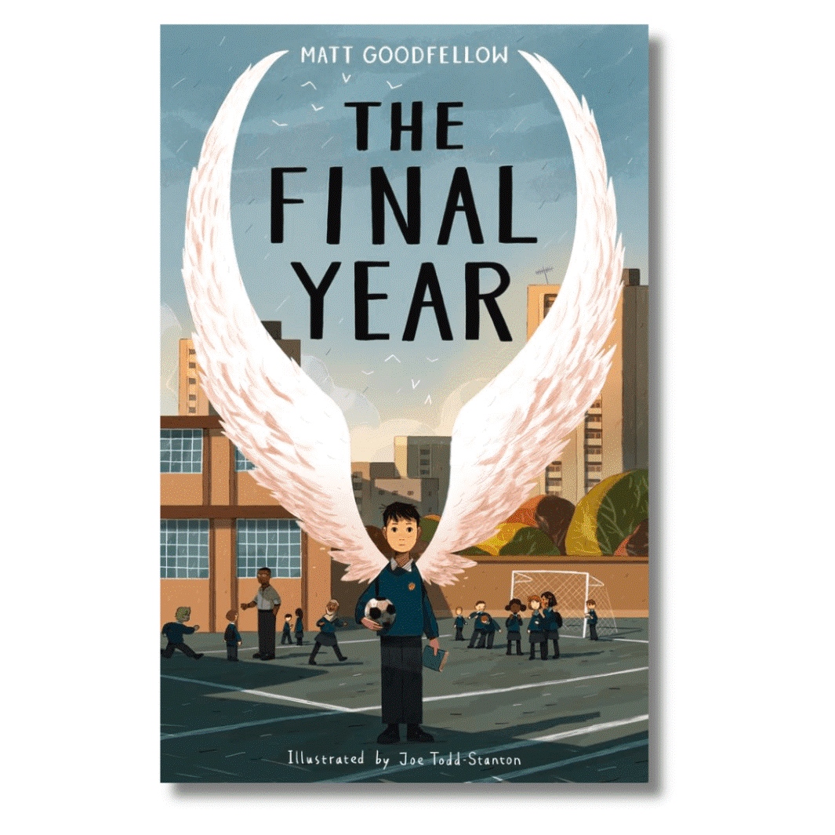

.

RE
Christians and how to live: ‘What would Jesus do?’

Why do some people believe in God and some people not?

Music
Songs of World War 2
- To know that ‘Pack up your troubles in your old kit bag’ and ‘We’ll meet again’ are examples of songs popular during WW2.
- To know that the Solfa syllables represent the pitches in an octave.
- To know that a ‘counter-subject’ or ‘counter-melody’ provides contrast to the main melody.
- To know that a counter-melody is different to harmony because it uses a different rhythm as well as complementary notes.

P.E
We will be covering skills and tactics linked to the following activities.
- Games
- Athletics
- Swimming

Computing
Computer systems and networks, exploring AI
Key Knowledge
- AI is artificial intelligence and is used in everyday life.
- AI is trained on data to recognise patterns and generate outputs.
- AI can be used to generate written content.
- AI can be used to create visual content like pictures.
Online Safety
- Possible dangers online and how to stay safe.
- The pros and cons of online communication.
- That information on the internet might not be true or correct and ways of checking validity.
- What to do if they experience bullying online.

Pluto Class
Summer Term Overview 2026

