Isolation Learning
Please use the resources and website listed below to access should you need to isolate. Any problems please contact me at dwiggall@sharpness.gloucs.sch.uk
Subject | Resources
  Reading | https://www.activelearnprimary.co.uk  https://readtheory.org/  Please contact me for your login details.
  Writing | https://www.pobble365.com/  Complete the tasks linked to the days picture prompt.
  Maths | https://www.topmarks.co.uk  Please find appropriate games to play. Arithmakit questions have been uploaded separately. https://ttrockstars.com/
  Topic | https://www.bbc.co.uk/bitesize/topics/zwmpfg8  Use the BBC home learning to learn more about the Roman Empire. Remember you also have topic home work to do.
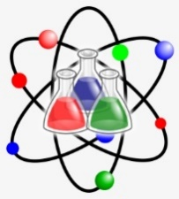  Science | https://www.bbc.co.uk/bitesize/topics/zrffr82  Use the BBC home learning to learn more about healthy eating. Watch the videos and complete the activities.
  PE | https://login.wowactive.co.uk/#!/login  Login and download your activity program to complete at home.
  Computing | https://projects.raspberrypi.org/en/codeclub/scratch-module-  Use scratch to complete the module one lessons featured on the website.
  Art/DT | Complete a still life using any medium you would like.
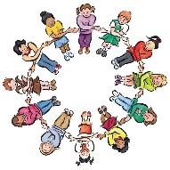  PHSE | https://www.bbc.co.uk/bitesize/topics/ztkk7ty/resources/1 Complete these BBC Bitsize lessons on self-awareness. You could also keep a diary of your days during isolation.
  RE | https://www.bbc.co.uk/bitesize/topics/znwhfg8  Watch the videos and complete the activities to support your understanding of the Judaism religion.
  French | https://www.bbc.co.uk/bitesize/topics/zjcbrj6/articles/z3kgn9q  Learn to tlk about French Towns using these resources to support you.

These websites and resources are to support your learning. Please only do what is manageable for you; there is no expectation for you to complete every activity. I would love for you to share any work you complete with me.

