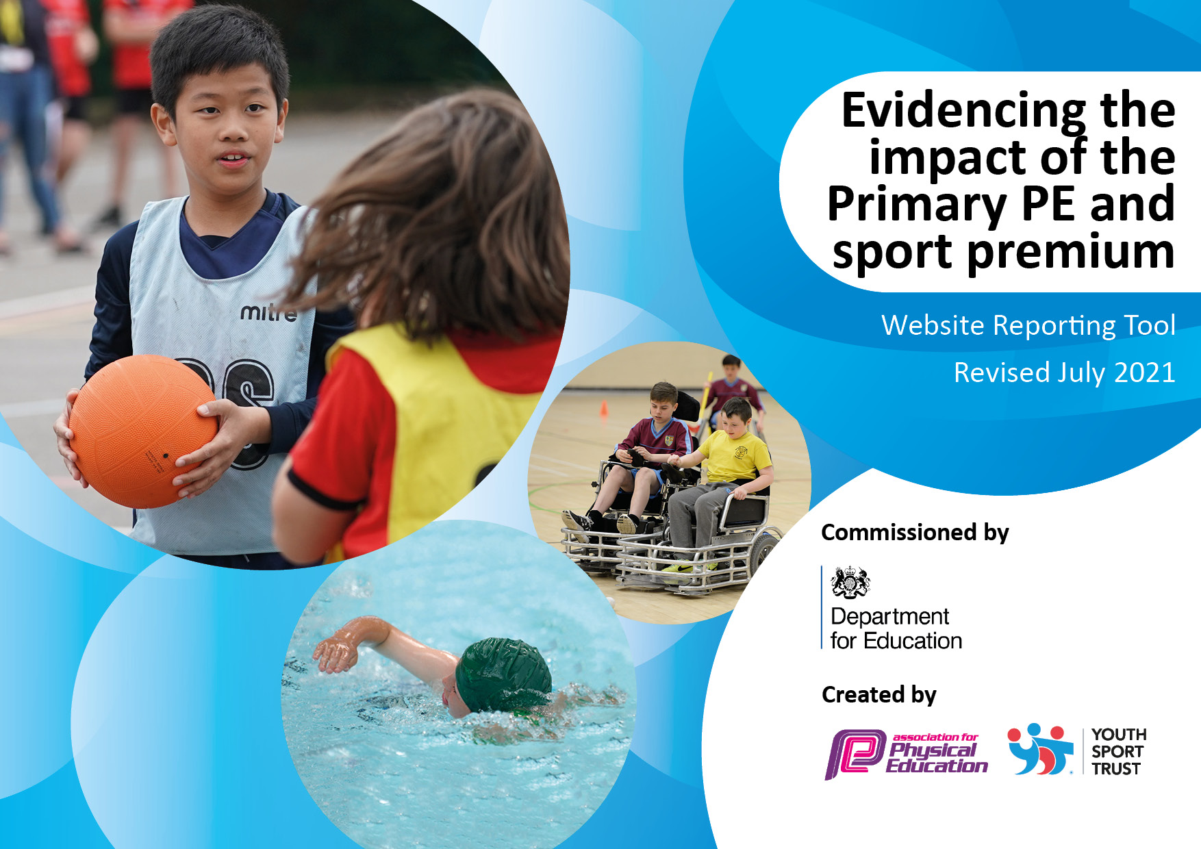
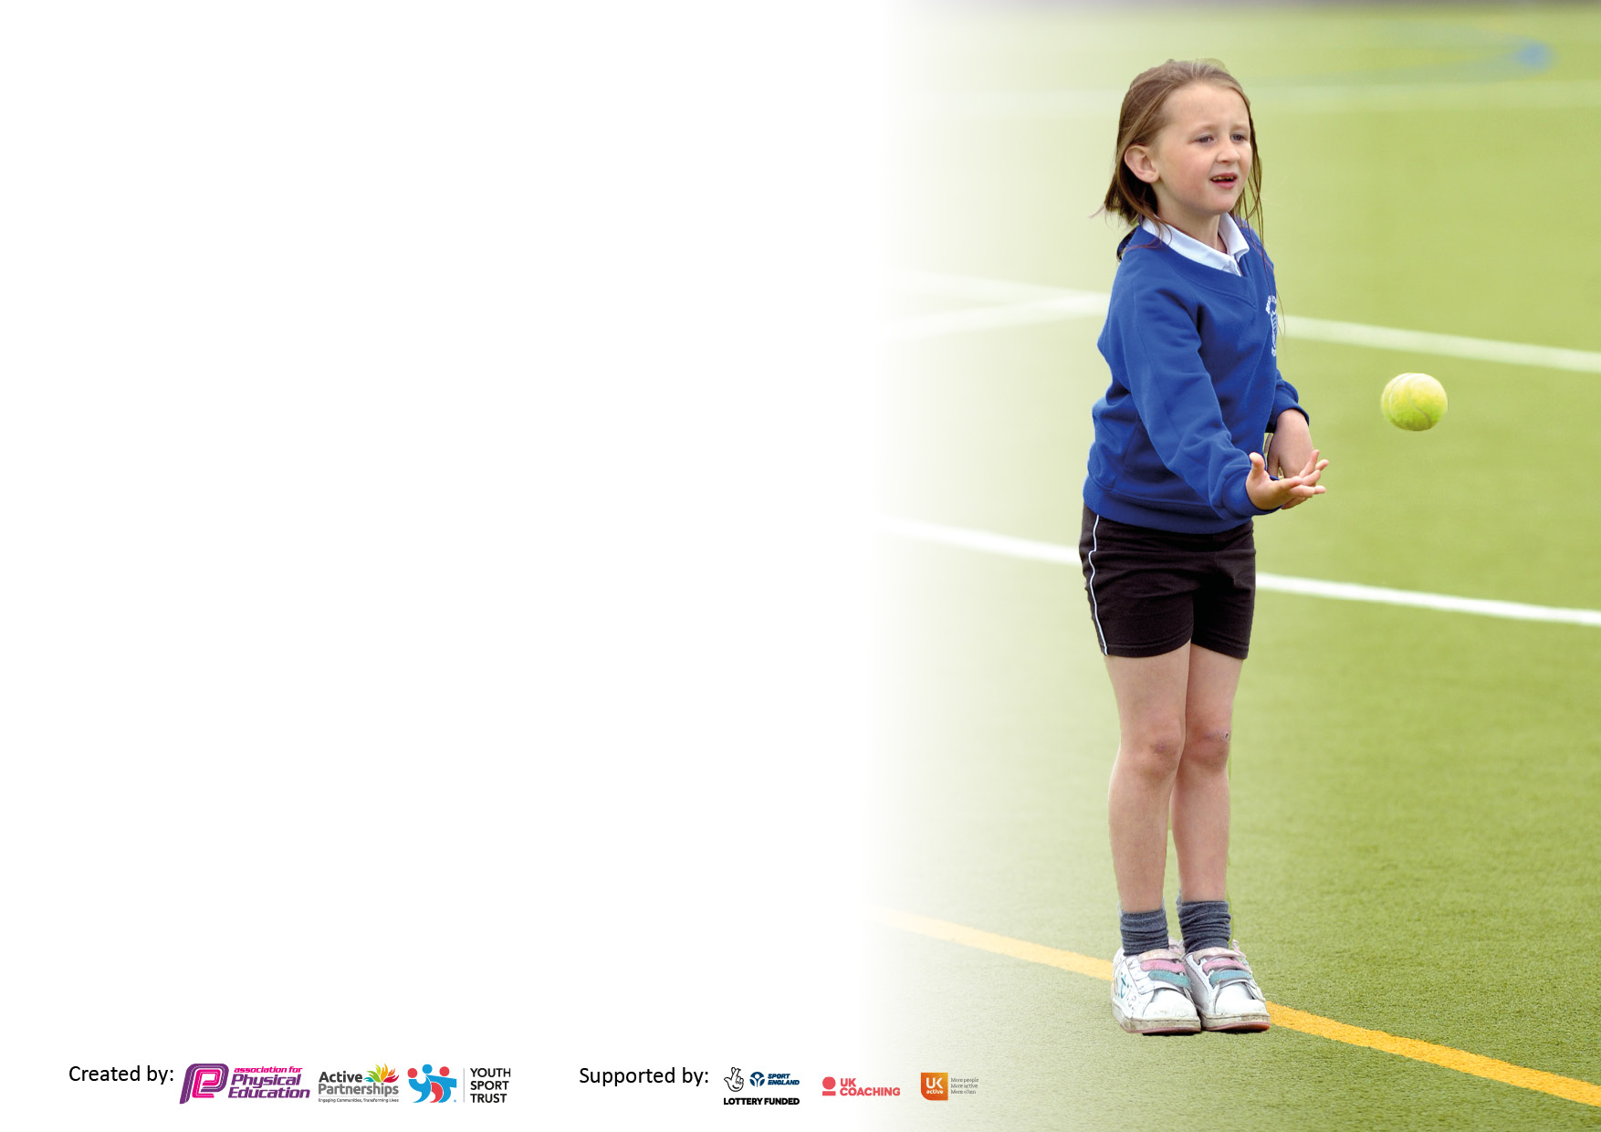

It is important that your grant is used effectively and based on school need. The Education Inspection Framework makes clear there will be a focus on ‘whether leaders and those responsible for governors all understand their respective roles and perform these in a way that enhances the effectiveness of the school’.

Under the Quality of Education Ofsted inspectors consider:
Intent - Curriculum design, coverage and appropriateness
Implementation - Curriculum delivery, Teaching (pedagogy) and Assessment
Impact - Attainment and progress

To assist schools with common transferable language this template has been developed to utilise the same three headings which should make your plans easily transferable between working documents.

Schools must use the funding to make additional and sustainable improvements to the quality of Physical Education, School Sport and Physical Activity (PESSPA) they offer. This means that you should use the Primary PE and sport premium to:

- Develop or add to the PESSPA activities that your school already offer
- Build capacity and capability within the school to ensure that improvements made now will benefit pupils joining the school in future years
- The Primary PE and sport premium should not be used to fund capital spend projects; the school’s budget should fund these.

Pleasevisitgov.ukfortherevisedDfEguidanceincludingthe5keyindicatorsacrosswhichschoolsshoulddemonstrate animprovement.Thisdocumentwillhelpyoutoreviewyourprovisionandtoreportyourspend.DfEencouragesschools to use this template as an effective way of meeting the reporting requirements of the Primary PE and sport premium.

We recommend you start by reflecting on the impact of current provision and reviewing the previous spend.

Schools are required to publish details of how they spend this funding, including any under-spend from 2019/2020, as well as on the impact it has on pupils’ PE and sport participation and attainment. All funding must be spent by 31st July 2022.

We recommend regularly updating the table and publishing it on your website throughout the year. This evidences your ongoing self-evaluation of how you are using the funding to secure maximum, sustainable impact. Final copy must be posted on your website by the end of the academic year and no later than the 31st July 2021. To see an example of how to complete the table please click HERE.


Created by: Supported by:

Details with regard to funding
Please complete the table below.

Total amount carried over from 2022/23
Total amount allocated for 2022/23
How much (if any) do you intend to carry over from this total fund into 2023/24? | £8083
Total amount allocated for 2023/24 | £16,926
Total amount of funding for 2023/24. To be spent and reported on by 31st July 2024. | £25,009
Swimming Data
Please report on your Swimming Data below.

Meeting national curriculum requirements for swimming and water safety.  N.B. Complete this section to your best ability. For example you might have practised safe self-rescue techniques on dry land which you can then transfer to the pool when school swimming restarts.  Due to exceptional circumstances priority should be given to ensuring that pupils can perform safe self rescue even if they do not fully meet the first two requirements of the NC programme of study | 100%
What percentage of your current Year 6 cohort swim competently, confidently and proficiently over a distance of at least 25 metres?  N.B. Even though your pupils may swim in another year please report on their attainment on leaving primary school at the end of the summer term 2023.  Please see note above | 100%
What percentage of your current Year 6 cohort use a range of strokes effectively [for example, front crawl, backstroke and breaststroke]?  Please see note above | 100%
What percentage of your current Year 6 cohort perform safe self-rescue in different water-based situations? | 100%
Schools can choose to use the Primary PE and sport premium to provide additional provision for swimming but this must be for activity over and above the national curriculum requirements. Have you used it in this way? | Yes/No

Action Plan and Budget Tracking
Capture your intended annual spend against the 5 key indicators. Clarify the success criteria and evidence of impact that you intend to measure to evaluate for pupils today and for the future.

 | Academic Year: 2023/24 |  | Total fund allocated: |  | Date Updated:
 | Key indicator 1: The engagement of all pupils in regular physical activity – Chief Medical Officers guidelines recommend that primary school pupils undertake at least 30 minutes of physical activity a day in school |  |  |  |  |  |  |  | Percentage of total allocation:
 |  |  |  |  |  |  |  |  | 40%
 | Intent |  | Implementation |  |  |  | Impact
All children receive at least 2 hours of PE every week by a PE Specialist/ class teacher.  Impact: High quality PE for all children |  | Atlas/Sports Plus Sports Coaching  Monitoring of planning/ lessons |  | Funding allocated:  £6,444 |  | All children received quality first teaching. This has had a very positive impact on all children’s fitness, positivity towards sport and all- round skills and development. We have been awarded the GOLD school games mark to further highlight the dedication we show to developing sport and competition across the school and community.
Children to take part in 15 minutes daily exercise at the start of the day. Children encouraged to increase the effort e.g. walkers encouraged to jog. Motivational tools used such as trackers/ target sheets  Impact: Improved effort during the morning run. Improved self esteem |  | Use of music to increase engagement – use high tempo songs to give a rhythm to run  to |  | £345.00 |  | All children now complete far more laps than at the start of the year. The morning run also has a very positive impact on their mental health and their approach to work in the morning as indicated by pupil conferencing. The children enjoy the music and encouragement and are far more resilient when it comes to running in different weathers.
Additional sport accessed through links with Atlas Sports – Bronze package for participation  Impact: Increased sporting opportunities for all. A range of new sports offered and an opportunity to compete against other schools. |  | Affiliation through School games bronze package |  | See above |  | This affiliation has allowed far more children to participate in tournaments and sports not traditionally played in school including roller hockey and ultimate frisbee.
New equipment to support playtimes including gym equipment  Impact: An increase in the number of children who are physically active during break times |  | New equipment used to support development of children’s exercise during free time. |  | £3300 |  | Children’s playtimes now far more engaging and focused with new equipment to encourage collaborative games and play.
 | Key indicator 2: The profile of PESSPA being raised across the school as a tool for whole school improvement |  |  |  |  |  |  |  | Percentage of total allocation:
 |  |  |  |  |  |  |  |  | 7%
 | Intent |  | Implementation |  |  |  | Impact
 | Dedicated sports coach to run PE lessons weekly for each child delivering high quality instruction and opportunities to participate in new sports and activities.  Impact: Children have a wider knowledge of sport and have had opportunities to play new sports. |  | Meet coach half termly to discuss planning for the new term and any new resources which maybe need. |  | Funding allocated:  See above |  | Very positive impact on PE sessions – new sports played, new skills learnt, CPD for teachers. Far more engagement in new sports including ultimate Frisbee and roller hockey which has really inspired the children and allowed them to build links with known sports and transfer skills and tactics.
 | Children encouraged to lead healthy lifestyles and attend clubs provided in school supporting mental well-being.  Impact: Children equipped with greater understanding of how to be healthy both physically and mentally. |  | Complete pupil questionnaire to establish what clubs they would like. Continue to provide clubs so that we can participate in local tournaments. |  | £500 |  | PE questionnaire showed very positive impact on children’s enjoyment, desire to participate and far greater attendance at clubs. Children are taught about the body and mind and have a good understanding of how we can keep ourselves healthy – this is taught through PE and PHSCE lessons.
 | Additional sport accessed through links with Atlas Sports – Bronze package for participation  Impact: Increased sporting opportunities for all. A range of new sports offered and an opportunity to compete against other schools. |  |  |  | See above |  | This affiliation has allowed far more children to participate in tournaments and sports not traditionally played in school including ultimate frisbee and roller hockey. Pupils have spoken of how they enjoyed the new activities and tournaments on offer.
 | Children’s participation in after school clubs/out of school clubs and views towards exercise/PE are explored to support further developments/priorities  Impact: Increased sporting opportunities, increased participation in |  | Pupil conferencing to establish children’s participation/ attitude towards PE |  | £1250 (Supply costs for PE coordinator release time) |  | Participation in after school clubs has increased, more sports are covered throughout the year. There is a greater number of sports clubs available for KS1 meaning the love of sport/PE has a lasting impact throughout their the children’s time in school.
 | Celebration assemblies where  children show off their certificates,  achievements from activities in  school, inter school tournaments and  festivals as well as out of school  activities.  Impact: Improved self esteem |  | Whole school celebration  Sports council to create celebration board |  | £0 |  | Sports board created and tournaments, sporting achievements and out of school sporting successes were displayed and celebrated. There has been a focus on celebrating out of school achievements in assembly and this is then referenced on the school newsletter. This has had a very positive impact on children’s self-esteem.
 | Establish annual awards as a regular part of end of year celebrations.  Impact: Children recognised for effort, progress and excellence in a range of sports |  | Order trophies for end of year assembly |  | £ 100 |  | The reintroduction of our end of year awards had a very positive impact on the children and was a valuable addition to our end of year celebrations – rewarding effort and participation across a range of sports.

Key indicator 3: Increased confidence, knowledge and skills of all staff in teaching PE and sport |  |  |  | Percentage of total allocation:
 |  |  |  | 24%
Intent | Implementation |  | Impact
CPD provided by Sports coach and outside agencies such as Gloucester Rugby  Impact: Confident staff who provide high quality, engaging lessons which motivate pupils to achieve their potential. | High quality coaching ideas provided for staff to use within the classroom | £1000 | Excellent CPD has provided teachers with far greater confidence to teach sports rather just skills. This has meant more purposeful lessons focused on building towards games with a far greater understanding.  Gloucester rugby sessions were well coached and received very positive feedback from the children. The sessions focused on all the core values of rugby.
Continue to use assessment to ensure all skills are taught and progression of skills is evident  Impact: Staff will be able to identify achievements of all children in their classes and their next steps in learning. PE Lead / SLT can track key groups across the school to ensure their needs are being met. | Staff meeting re: PE assessment  Monitoring of assessment | £2000 | PE Pal used to assess children this has been useful to develop lessons to improve skills highlighted by the tracker this has led to far more bespoke teaching and focused intervention when needed. All children have more awareness of their own skills and are able too talk effectively about their progress but also refer to their next steps and how they might achieve those.
Provision of high quality equipment.  Impact: Staff are able to deliver lessons effectively with the correct equipment | Purchase high quality equipment which will be maintained to a good condition in order to enable staff to confidently deliver a range of different sports and activities. | £3000 | New sports equipment has had a very positive impact on allowing more children to participate in lessons rather than having to wat their turn for equipment to become available. The children get far more time to practise skills and develop in the sport they are playing as the extra equipment allows them to.
CPD for staff where needed e.g. the new scoring system for dynamo cricket or playing rules for netball.  Impact: Improved staff knowledge to ensure correct teaching of sports. |  | £0 | Very positive impact on lessons and the children’s participation in tournaments. Staffs confidence is higher therefore they are able to deliver much higher quality lessons and which has a far greater degree of impact on the children.
Key indicator 4: Broader experience of a range of sports and activities offered to all pupils |  |  |  | Percentage of total allocation:
 |  |  |  | 10%
Intent | Implementation |  | Impact
Continue to develop the children’s knowledge of sports from other countries and cultures.  Impact: Children have knowledge of sports from around the world and an understanding of how important sport can be to a culture. | Atlas Sports to introduce a wide range of new sports from different cultures.  Affiliation through School Games to provide different opportunities | See above | Children have been exposed to dance workshops and a variety of sports from other cultures including Antarctica and Japan.
Children are provided with a number of physical activity experiences  Impact: children exposed to a wide range of different sports. Children play new sports through signposted clubs. | Shropshire  Gloucestershire Cricket  Forest Green Rovers  Atlas Sports competitions  Chance to Shine cricket  Gloucester Rugby coaching  Swimming for all year groups | £2500 | Children have taken part in numerous sporting experiences this year from rugby coaching for KS2 to a multi sports event at the local secondary school for KS1. All children have had the opportunity to be a part of multiple sporting opportunities alongside their 2 hours of dedicated PE time.
Provide extra-curricular activities in a range of sports/activities  Impact: Increased percentage of children attending after school clubs | Pupil conferencing  Atlas Sports after school club (KS1/2) | See above | The number of pupils accessing after school clubs has remained constant in KS2 while there has been an increase in KS1 pupils accessing sport based after school activities. The number of girls taking part in after school clubs has also increased.

Key indicator 5: Increased participation in competitive sport |  |  |  | Percentage of total allocation:
 |  |  |  | 13%
Intent | Implementation |  | Impact
Provide all children in KS1 and KS2 the opportunity to compete in competitive sport.  Impact: More children entering intra and inter school competitions in different sports | Affiliate and enter a wider range of competitions through Dursley/Wotton association and School Games.  Sports council to organise intra school competitions. | £1,200 | Affiliation through Durlsey and District, Wotton and Atlas has meant we have competed or entered teams in both boys’ and girls’ football –qualifying in the later round of the girls tournament. We took part in rugby tournaments, cricket, rounders and athletics. This has been across KS2 while KS1 have taken part in a district wide multi sports festival.  We have increased the number of children competing in intra school tournaments as well as our traditional house swimming and sports day events.
Enter competitions within the district aimed at those less engaged/least active children  Impact: Boost self-esteem and change attitudes towards PE for the less engaged/least active children | Penathlon events through Wotton/ Dursley association | £2000 (transport) | We have been able to take children who have previously been disengaged or reluctant to compete in competitive sport to football tournaments, athletics and rugby. We have also ensured we have looked for opportunities for the less engaged children to compete in school to build their resilience. Feedback was very positive from all children as seen through pupil voice and conferencing.
Improve links with local sports clubs  Impact: Children signposted to local clubs | PE coordinator to contact local clubs and organise taster days/ assemblies/leaflet drops.  PE lead/ Sports councillors to add local club contacts to display |  | We have formed strong links with Dursley rugby club, several local football teams and Cam cricket club where we have signposted a number of children and parents. This has had a positive impact on not only the children’s sporting development but also social skills as they move on to secondary school.
Celebrate sporting achievement through display board and Sports newsletter.  Impact: Children have an increased sense of pride and achievement through getting to share sporting success. | PE Coordinator to meet sports council in order to facilitate displays and the newsletter. | £150 | Sports board created and tournaments, sporting achievements and out of school sporting successes were displayed and celebrated. Out of school sporting achievements are now regularly celebrated in assembly and these then are added to our fortnightly school newsletter.
Share sporting success with local news papers and on social media.  Impact: Increase the awareness of sport at Sharpness and help build links with local sports clubs. | Share sporting success with all local news papers and build up links with local journalists. | £0 | We have shared all sporting achievements with local press and on social media this has had such a positive impact on the reputation of the school and the sense of pride in the children who attend.

Signed off by
Head Teacher: | Helen Buckingham
Date:
Subject Leader: | Leeanna Ashford
Date:
Governor:
Date:

