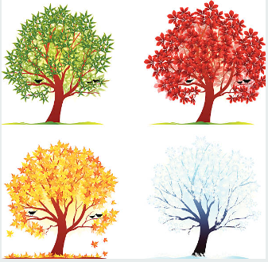

Dear Parents and Carers,

Welcome back to the start the Autumn Term. We hope you had a restful summer break and the children are ready for another fun-packed term at school.

This term we will be using Kapow for all our topic-based subjects. We will be exploring senses and materials in Science; in geography and history our topics will be ‘Where am I?’, and ‘What is History?’. We will also be covering the other foundation subjects alongside these.

We are currently revisiting our phonic sounds that the children learned last year, when we move onto our new sounds I will send home an activity sheet covering the sounds that we are focussing on for that week. We will not be doing a formal spelling test, weekly spellings will be applied and assessed through the children’s sentence level work. Maths homework books will come home on a Friday; please could I have these returned by the following Thursday so that I can mark them.

Your child should be heard read daily, at home, in order to make the relevant progress throughout the year. Please sign the book (in the boxed marked with appropriate day) if you have heard them read.

Children will need to have their named P.E. kit in school everyday. Our PE days this term are Monday and Friday. Could children with long hair also keep a spare hair band in their P.E. kit in order to tie their hair back. Children with earrings will be expected to take them out or cover them with tape, which will need to be provided and kept in their P.E. bags.

Due to limited cloakroom space in Venus, could I politely ask that children only bring book bags into school to carry their reading books and school letters. Don’t forget the children are welcome to bring in a water bottle to use in school, we do have cups available if they forget them.

Please feel free to pop in anytime if you have any questions.
Best wishes,

Mrs Clarke

Sharpness Primary School
Venus Class
Autumn 2026

